Project Report
ExoHabitAI – Habitability of Exoplanets

1. Introduction
The discovery of exoplanets has grown exponentially due to advancements in space telescopes and astronomical surveys such as Kepler and TESS. However, identifying which of these planets could potentially support life remains a complex scientific challenge. Habitability depends on multiple astrophysical parameters such as planetary size, mass, temperature, and orbital characteristics.
ExoHabitAI is a machine learning–based system designed to analyze exoplanetary data and predict the likelihood of a planet being habitable. By integrating data preprocessing, predictive modeling, ranking algorithms, and visualization techniques into a full-stack web application, this project demonstrates the practical application of artificial intelligence in space science.

2. Objectives
The primary objectives of ExoHabitAI are:
• To develop a machine learning model capable of predicting exoplanet habitability
• To compute a habitability score and rank exoplanets accordingly
• To provide interactive data visualizations for better interpretation
• To design and deploy a full-stack machine learning application
• To demonstrate real-world ML deployment using modern web technologies

3. Dataset Description
The dataset used in this project contains validated exoplanet data collected from publicly available astronomical databases. It includes both raw and cleaned versions of the data.
Key Features Used:
• Planet Radius (pl_rade) – Indicates the size of the planet
• Planet Mass (pl_bmasse) – Helps determine gravitational stability
• Equilibrium Temperature (pl_eqt) – Important for liquid water conditions
• Orbital Period (pl_orbper) – Reflects distance from the host star
Data Files:
• exoplanets_raw.csv
• exoplanets_cleaned.csv
• exoplanets_validated.csv

4. Methodology
4.1 Data Preprocessing
• Removed incomplete and inconsistent records
• Handled missing values using statistical imputation
• Normalized numerical features
• Addressed class imbalance using SMOTE techniques
• Validated feature ranges using domain knowledge
4.2 Exploratory Data Analysis (EDA)
• Correlation analysis between features
• Distribution plots for key parameters
• PCA and t-SNE for dimensionality reduction
• Bivariate and multivariate analysis
4.3 Model Building
• Trained baseline models for comparison
• Implemented advanced models using:
◦ Scikit-learn
◦ XGBoost
• Evaluated models using accuracy and classification metrics
• Persisted the final trained model using joblib/pickle
4.4 Backend Development
• Flask-based REST API
• Modular architecture using Blueprints
• SQLAlchemy for database operations
• Endpoints for:
◦ Habitability prediction
◦ Ranking retrieval
◦ Data visualization support
4.5 Frontend Development
• Responsive UI built with HTML and CSS
• JavaScript for interactivity
• Axios for API communication
• Plotly.js for interactive charts
• Separate pages for:
◦ Prediction
◦ Ranking table
◦ Visual analytics

5. Results and Outputs
• Accurate classification of habitable vs non-habitable planets
• Ranked list of top 20 potentially habitable exoplanets
• Interactive scatter plots and histograms
• Exported reports in CSV and Excel formats
• Model artifacts stored for reuse and inspection
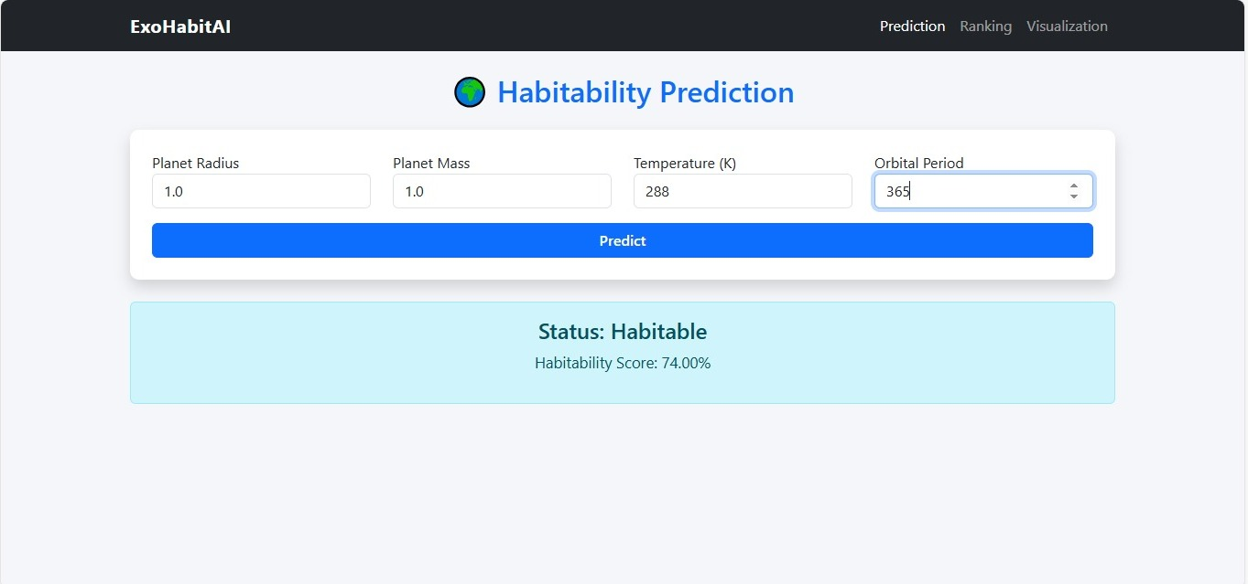
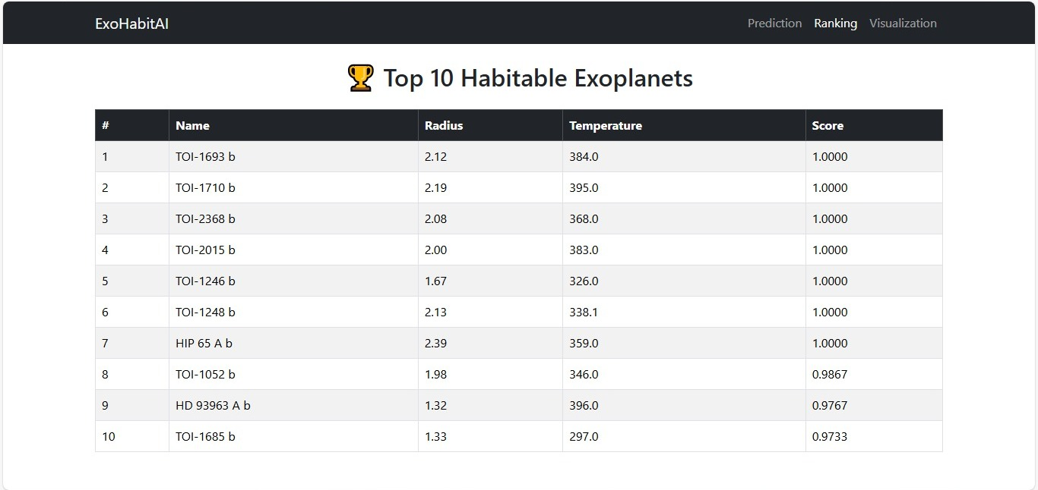
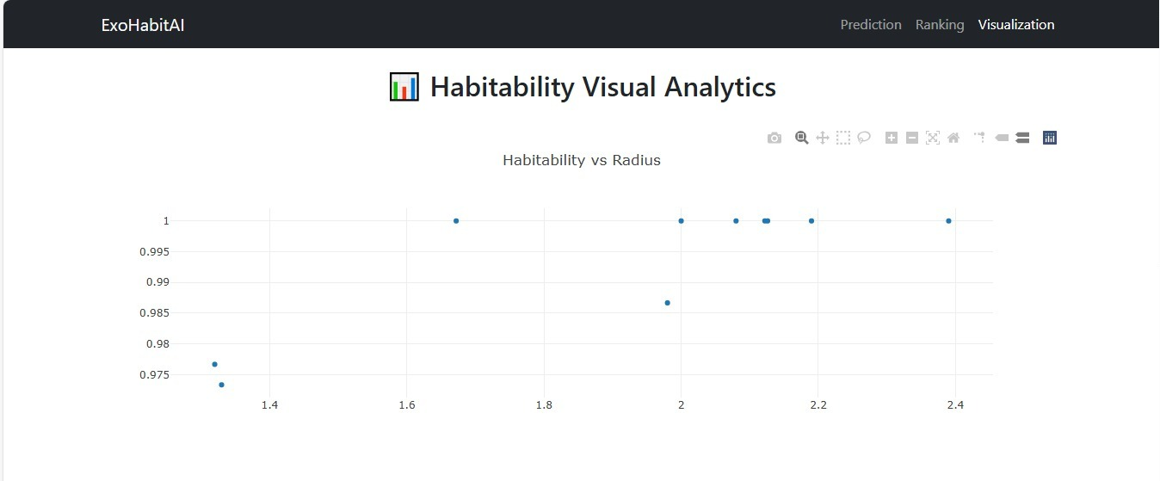
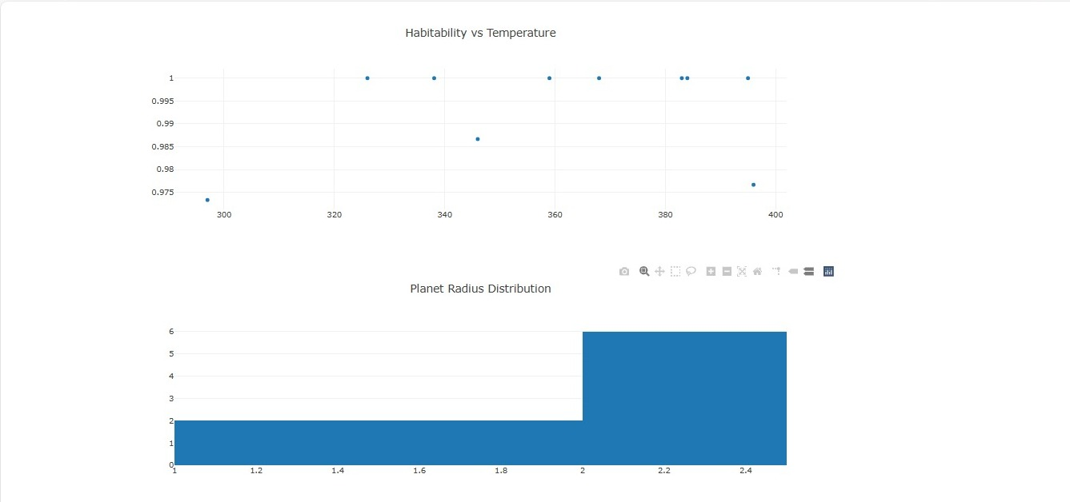

6. Deployment
The application is designed to be deployment-ready and follows industry practices.
Deployment Stack:
• Gunicorn – Production WSGI server
• Render – Cloud deployment platform
• Environment variables for configuration
• Static frontend hosting via Flask
The system supports both local development and cloud deployment without code changes.

7. System Architecture
• Frontend: HTML, CSS, JavaScript, Plotly
• Backend: Flask, SQLAlchemy
• ML Layer: Scikit-learn, XGBoost
• Storage: CSV files, model artifacts
• Deployment: Render + Gunicorn

8. Conclusion
ExoHabitAI successfully demonstrates how machine learning can be integrated with web technologies to address real-world scientific problems. The project highlights the complete lifecycle of an ML system—from data collection and preprocessing to model deployment and visualization—making it both academically valuable and industry-relevant.

9. Future Scope
• Integration of real-time astronomical data APIs
• Inclusion of additional astrophysical features
• Deep learning–based prediction models
• Advanced dashboards using React or Dash
• Mobile-friendly UI enhancements

10. Key Learnings
• End-to-end ML project development
• Handling real-world scientific datasets
• Model deployment challenges and solutions
• Full-stack integration of ML systems
• Cloud deployment best practices

